MPT 651 – MUNICIPAL ENGINEERING SYSTEMS

Final Exam – April 21st , 2021 8:00 am – 8:00 pm

Name:

- Total marks = 100
- You may use the back of the exam pages as additional work space.
- Total time = 2 hours

- Name and briefly describe the two (2) types of pumping stations (wells) when dealing with forcemains and describe the difference between the two. (3)

i)Dry wells ii)Wet wells
In dry wells the sewerage is collected in a separate well or pit from where the pump motors and controls are located.
Wet wells pumps and motors are located in the same chamber into which the sewerage flows

- What are the THREE main goals of Stormwater Management? (3)

- Water quality control
- Water quantity control
- Water Balance

- Identify each of the following equations (name them): (4)
Rational Equation

Q = CIA / 360

Manning’s equation

Q = AR^{2/3} S^{1/2} n⁻¹

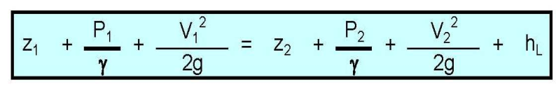
Bernoulli’s equation

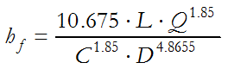
Hazen-Williams equation

of 10 pts
- When designing a road, list Traffic Factors that influence pavement design: (5)

- Traffic volumes
- Types of vehicles
- Public transportation type
- Public transportation need
- Trip type e.g. (shopping through traffic)

- List factors that influence the type and severity of erosion. (4)

- Vegetation cover
- Topography
- Soil permeability
- Precipitation

- List as many E&SC BMP’s as you can. (8)

- Mechanical seeding
- Terra seeding
- Hydro seeding
- scarification
- Silt Fence
- Diversion Swales
- Mud Mats
- Blanket, Mats and Nets

- List the three (3) types of basic methods for protecting workers against cave-ins. (3)
- Slopping
- Shoring
- Hydraulic support systems

of 20 pts

- Calculate the height of a trench box for a 2100mm storm sewer. (10)
- Maintain 600mm clearance on either side of the pipe
- Maintain 600mm bench at top of the shoring system.
- Maintain 300mm clearance from top of soil to top of trench box.
- Label all dimensions in mm.

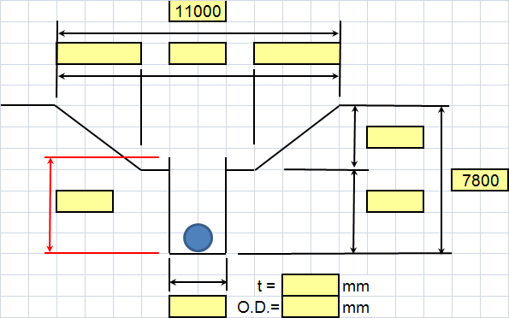
3650
4000
3650
4750
3650
4150
2500
200
3700

- A town is 3.5 km from its water source and 12m above it. The watermain between the town and the water source is 375 mm in diameter with a roughness coefficient of 110. The starting pressure at the water source is 800 kPa and the residual pressure at town is 300 kPA. Water is also stored in a water tower that is 2.5 km beyond the town with an elevation of 70m. The watermain between the town and the water tower is 250 mm in diameter (C = 100). Specific weight is 9.8 as always. Velocity is negligible. (10)

- Determine Q_{T} at the town. (PLEASE SHOW SOME CALCULATIONS)

Town tower

Tower TOWN

Coefficient = 100
Pressure(x)= 8kpa
Residual positive=300Kpa
C=100
Weight =9.8
Q_{T} OF The Following

P/Y=Pressure head
Z=Elevation head
hL=friction loss
C=co-efficient
R=Radius
S=Slope of the gradient

Hence
Qt=0.849CAR^{O.63}

C=100
R=RADIUS
S=SLOPE

QT=0.849(100)250^{0.63}70.⁰⁵⁴ FROM THE THEOREM

V=negligible
1 +800+70=300+12+1/+ hl
2(9.8) 2(9.8)

hl= 870 - 312 = 29.0317

2(9.8) 2(9.8)

Qt =0.849(100)250^{0.63}*70^{0.54}

- Please complete the design spreadsheet for the sanitary sewer layout plan provided (next 2 pages). You’ll need to size ALL (five in total) legs of sanitary sewer ensuring the following: (25)

- Flow within the pipe cannot exceed 80% of the capacity of the pipe;
- Assume n = 0.013;
- Assume 450 L/cap/day
- You must show at least one sewer leg’s worth of detailed calculations (by hand) in order to get full marks (place calculations below).

(ADDITIONAL WORKSPACE AS REQ’D)

- Please complete the design spreadsheet for the storm sewer layout and drainage plan provided (25)

- Flow within the pipe cannot exceed 80% of the capacity of the pipe;
- Assume n = 0.013;
- You must show at least one sewer leg’s worth of detailed calculations in order to get full marks (place calculations below). BE SURE TO CALCULATE THE ACTUAL VELOCITY BY HAND (SHOW WORK) FOR THE FIRST LEG (this is noted on spreadsheet)

(ADDITIONAL WORKSPACE AS REQ’D)

